**3 HARI / 4 HARI**

**HARGA MULAI DARI**

**IDR1,95JUTA**

**HONGKONG FREE & EASY**

**KEBERANGKATAN SETIAP HARI - MIN 02 PAX**

**TRAVEL PERIODE : JUN - OCT 2019**

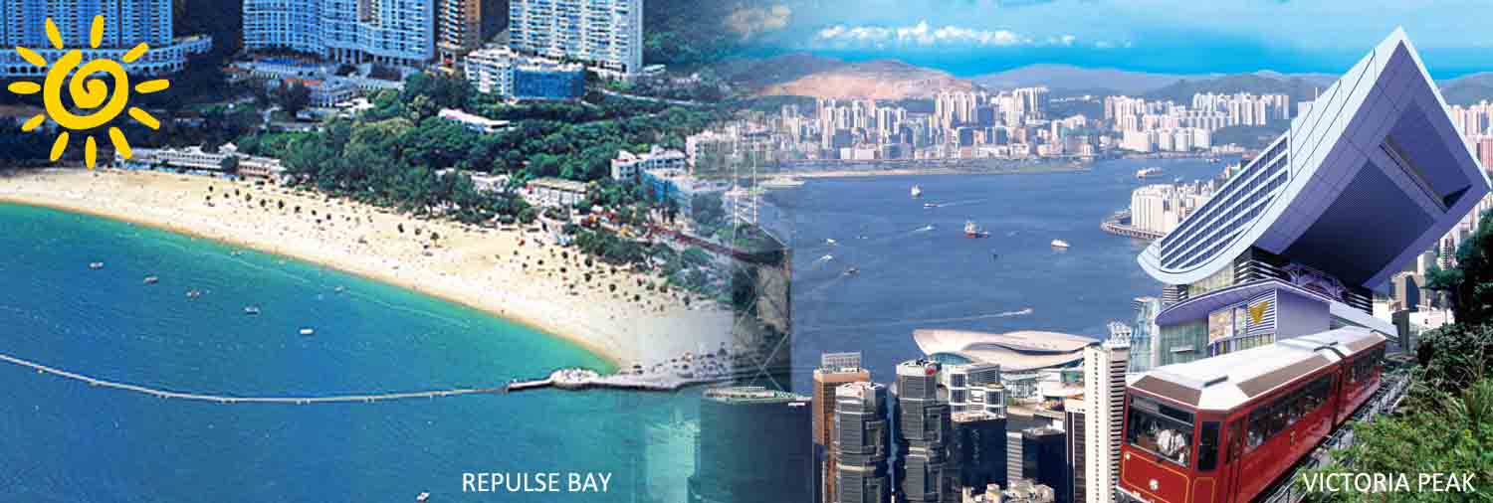

**TERMASUK:**

* **HOTEL**

02/03 malam menginap di hotel pilihan di Hongkong

* **TRANSFER**

Pengantaran AIRPORT-HOTEL-AIRPORT dengan Seat In Coach transfer (bersama tamu lain)

**ITINERARY:**

**_HARI 01:_ TIBA DI HONGKONG**

Bertemu di bandara Internasional Hongkong lalu diantar ke Hotel.

* **Penjemputan dimulai jam 08.00-21.00:**

* Bagi peserta yang tiba sebelum **jam 08.00AM**, harap menunggu hingga saat pengantaran pertama dimulai

* Bagi peserta yang tiba setelah **jam 21.00PM**, tidak ada pengantaran (Pengantaran dilakukan sendiri)

**_HARI 02:_ HONGKONG FREE PROGRAM (No Meal)**

**OPTIONAL HALFDAY CITY TOUR : IDR 250.000/pax**

Visit Aberdeen Fishing Village, Bauhinia Square, Victoria Peak (Mid Level) by Coach, Jewelry Shop & Souvenir Shop (Chocolate).

Tour akan berakhir di area Tsim Tsa Tsui East, dan anda akan dapat bebas berbelanja atau berkeliling di Tsim Tsa Tsui Promenade. Kembali ke Hotel dengan pengaturan dan biaya sendiri

**Mandatory Tipping selama City Tour : HKD 50/orang/city tour**

**_HARI 03:_ BERANGKAT DARI HONGKONG BAGI YANG MEMILIH PAKET 3HARI**

Acara bebas hingga waktu penjemputan dari Hotel ke Airport

**BAGI YANG MEMILIH PAKET 4 HARI (I-4ZN): FREE PROGRAM / OPTIONAL**

1. **FREE PROGRAM di HONG KONG:** Acara bebas.
2. **OPTIONAL TOUR HONG KONG**

**_HARI 04:_ BERANGKAT DARI HONGKONG**

Acara bebas hingga waktu penjemputan dari Hotel ke Airport

**KETERANGAN:**

* **Harga paket di bawah hanya berlaku apabila allotment kamar masih tersedia. Jika allotment kamar sudah habis, maka akan dikenakan surcharge tambahan (Ad-Hoc surcharge hotel) dari harga paket tersebut.**
* **Tidak ada pengembalian untuk uang Tour, Transfer Service atau apapun yang tidak digunakan selama mengikuti paket ini**
* **Harga dapat berubah sewaktu-waktu tanpa pemberitahuan terlebih dahulu**
* **Tour & Antar Jemput berdasarkan Seat In Coach (Guide Lokal hanya ada sewaktu city tour, antar jemput hanya ditemani oleh driver)**

**HARGA TOUR 3D/4D HONGKONG FREE & EASY (per orang/paket)**

**KEBERANGKATAN SETIAP HARI - MIN 02 PAX**

**TRAVEL PERIODE : JUN - OCT 2019**

HARGA BERDASARKAN IDR (K)* /PAX *:

|  |  |  |  |  |  |  |  |  |
| --- | --- | --- | --- | --- | --- | --- | --- | --- |
| HOTEL | STARS | PERIOD | 3D2N  I-3FE (AL) | | 4D3N  I-4ZN (AL) | | EXTEND NIGHT | |
| TWN | SGL SUPP | TWN | SGL  SUPP | TWN/SGL | EXT-BED |
| SILKA TSUEN WAN / SILKA FAR EAST / | 3 | JUN – SEP’19 | 1.950 | 1.600 | 2.650 | 2.210 | 1.450 | 560 |
| OCT’19 | 3.470 | 2.920 | 4.960 | 4.190 | 3.000 | 560 |
| WEEKEND SURCHARGE (JUMAT-SABTU) = IDR 290.000,-/R/N  PEAK DAY SURCHARGE (17 – 21 SEP’19 ) = IDR 290.000,-/R/N | | | | | | |
| SILKA WEST KOWLOON /  (no extra-bed available)  PANDA HOTEL / I-CLUB MA TAU WAI (New Hotel)  I-CLUB >>FREE<< SIMPLE CONTINENTAL A'bf For 2 pax only per room | 3 | JUN – SEP’19 | 1.980 | 1.660 | 2.750 | 2.300 | 1.510 | 560 |
| OCT’19 | 3.490 | 2.950 | 5.000 | 4.220 | 3.020 | 560 |
| WEEKEND SURCHARGE (JUMAT-SABTU) = IDR 290.000,-/R/N  PEAK DAY SURCHARGE ( 17 – 21 SEP’19 ) = IDR 290.000,-/R/N | | | | | | |
| LARGOS HOTEL /  (no extra-bed available)  SILKA SEAVIEW / | 3 | JUN – SEP’19 | 2.200 | 1.850 | 3.070 | 2.580 | 1.750 | 670 |
| OCT’19 | 3.580 | 3.010 | 5.130 | 4.330 | 3.110 | 670 |
| WEEKEND SURCHARGE (JUMAT-SABTU) = IDR 290.000,-/R/N  PEAK DAY SURCHARGE ( 17 – 21 SEP’19 ) = IDR 380.000,-/R/N | | | | | | |
| ROSEDALE KOWLOON /  L’HOTEL NINA | 4 | JUN – SEP’19 | 2.580 | 2.170 | 3.630 | 3.060 | 2.110 | 850 |
| OCT’19 | 3.750 | 3.160 | 5.400 | 4.550 | 3.290 | 850 |
| WEEKEND SURCHARGE (JUMAT-SABTU) = IDR 290.000,-/R/N  PEAK DAY SURCHARGE ( 17 – 21 SEP’19 ) = IDR 570.000,-/R/N | | | | | | |
| EMPIRE KOWLOON / KIMBERLEY HOTEL / | 4 | JUN – SEP’19 | 2.580 | 2.170 | 3.630 | 3.060 | 2.110 | 1.070 |
| OCT’19 | 4.090 | 3.450 | 5.900 | 4.980 | 3.620 | 1.070 |
| WEEKEND SURCHARGE (JUMAT-SABTU) = IDR 290.000,-/R/N  PEAKDAY SURCHARGE (17 – 21 SEP’19 ) = IDR 760.000,-/R/N | | | | | | |
| EATON HOTEL / PANORAMA HOTEL | 4 | JUN – SEP’19 | 2.800 | 2.350 | 3.970 | 3.350 | 2.330 | 1.070 |
| OCT’19 | 5.090 | 4.290 | 7.390 | 6.250 | 4.620 | 1.070 |
| WEEKEND SURCHARGE (JUMAT-SABTU) = IDR 290.000,-/R/N  PEAKDAY SURCHARGE (17 – 21 SEP’19) = IDR 850.000,-/R/N | | | | | | |
| ROYAL PLAZA ( DLX King Room ) | 4 | JUN – SEP’19 | 3.470 | 2.920 | 4.960 | 4.190 | 3.000 | 1.110 |
| OCT’19 | 5.090 | 4.290 | 7.390 | 6.250 | 4.620 | 1.110 |
| WEEKEND SURCHARGE (JUMAT-SABTU) = IDR 290.000,-/R/N  PEAKDAY SURCHARGE (17 – 21 SEP’19) = IDR 850.000,-/R/N | | | | | | |
| ROYAL GARDEN HOTEL / CORDIS at LANGHAM PLACE | 5 | JUN – SEP’19 | 4.130 | 3.480 | 5.960 | 5.030 | 3.670 | 1.220 |
| OCT’19 | 5.530 | 4.670 | 8.060 | 6.810 | 5.060 | 1.220 |
| WEEKEND SURCHARGE (JUMAT-SABTU) = IDR 290.000,-/R/N  PEAKDAY SURCHARGE (17 – 21 SEP’19) = IDR 950.000,-/R/N | | | | | | |
| CHILD (2-11yrs)(1A+1C) or EXT-BED = ADT TWN // CHILD (NO BED NO B'FAST)  untuk semua hotel : IDR 360,000/pax | | | | | | | | |

*K= Harga dalam Ribuan. Contoh: Harga IDR 1920 = IDR 1.920.000,-